The partner needs to provide the following things to create a new partner account

1. **Basic information**
2. Company name
3. Sub-domain name

Note : The users of sites which create by partner will use the following URL to login into the platform:

*https:// {subdomain}.platform.comm100.com*

1. Custom domain (Option)

If partner want to use custom domain, they need to provide this information, we can help them to configure the proxy server.

1. Website of their company
2. Contact Name
3. Contact Email
4. Contact Number
5. Contact Title
6. **Custom domain(Optional)**
7. **Nginx proxy server**
8. **Others**

**3.White Label(Optional)**

1. Product Name (if partner does not provide, the default product name is Comm100 Live Chat)

2. Branding Name (If partner does not provide, the default branding name is Comm100)

The screenshot blew is an example.

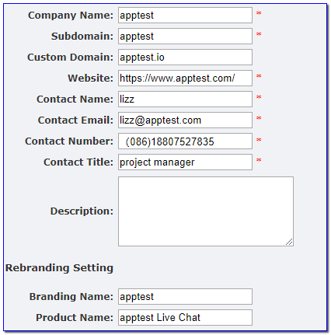

1. **Image files (You can get the sample from the attachment：images -example.zip）**
2. Logo

*SVG file, 136px by 25px, transparent background color*

*Name: {companyname}.svg*

1. Large Icon

*PNG file, 256px by 256px, solid background color,*

*name – {companyname}.logo256X256.png*

1. Small Icon

*PNG file, 64px by 64px, solid background color,*

*name – {companyname}.png*

1. Windows Electron Icon

*ICO file, 256px by 256px, transparent background color,*

*name – {companyname}.icon.ico*

1. Mac Electron Icon

*ICO file, 256px by 256px, transparent background color,*

*name – {companyname}.icon.icns*

1. Dmg-Background.png

*PNG file, name –{companyname}.dmg-background.png， it is used in mac eletron, Please refer to the attached picture*

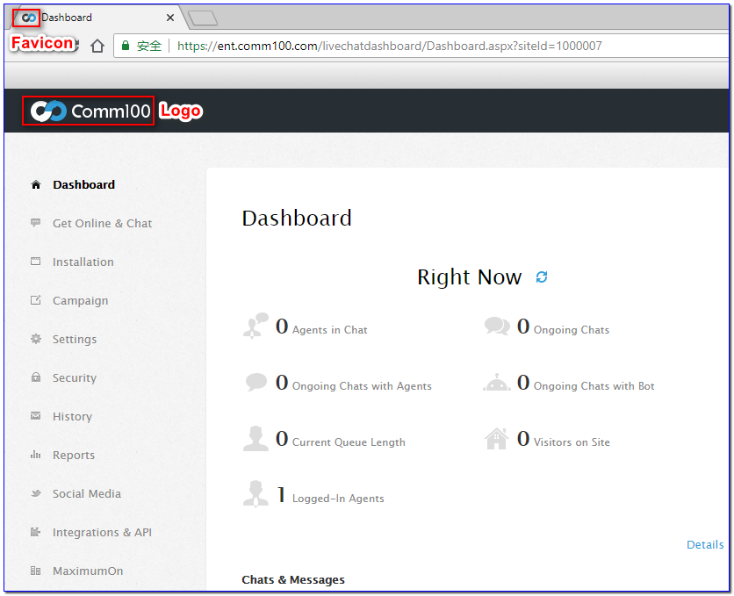

Notes: If the partner want to customize the display style of our product, they must tell us the detail requirement. In principle, only simple display style changes such as theme colors, fonts, menu styles, functional display images, etc. are acceptable.

We suggest that partners take a look at our products firstly and then decide how to modify the display styles. It is better to provide some design sketch to help us to understand the requirement.